COWBELLS
Offense 2016 Playbook

Our YEAR GOALS
Train HARD play HARD!!!
- Offense:
- Minimum of 27 points per game.
- Minimum of 4 yards per carry.
- Minimum of 8 yards per catch.
- Minimum of 80% redzone success.
- Minimum of 70% success on 3rd down.
- Minimum of 60% pass completion.
- Average less than 1 TO per game.
- Allow NO more than 1 sack per game.
- Produce, at least 3 point per every TO our defense brings us.
- No more than 20 yards penalty per Game.

- Our Spirit:
- OL: WHEN WE RUN I WILL BUILD A HIGHWAY!
- OL: WHEN WE PASS NO ONE TOUCHES OUR QB!
- FB: I WILL BREAK ANYONE THAT COMES MY WAY!
- FB: I RUN LIKE A BULLDOZER!
- HB: I WILL RUN HARD AND SWIFTLY, AND IF YOU STANK MY WAY I WILL PUNISH YOU!
- HB: I LL BLOCK HARD, AND CATCH SOFT!
- WR: I LL WILL RUN HARD AND CATCH SWIFTLY ANYTHING THAT COMES MY WAY!
- TE: I LL BLOCK HARD AND CATCH SOFTLY!
- QB: I LL COMPLETE ALL MY PASSES!
- QB: I LL BE A LEADER ON AND OFF THE FIELD!

Offense players terminology:
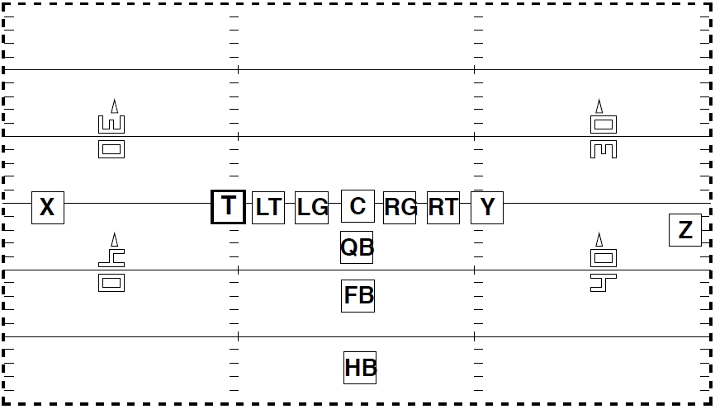
- QB: Quarterback
- C: Center
- RG: Right Guard
- RT: Right Tackle
- LG: Left Guard
- LT: Left Tackle
- Y: Tight End
- SE: Split End ( X )
- FL: Flanker ( Z )
- HB: Halfback ( HB or H )
- FB: Fullback (FB or F )
- W: Wingback
- T: 2nd TE

Other terminology:

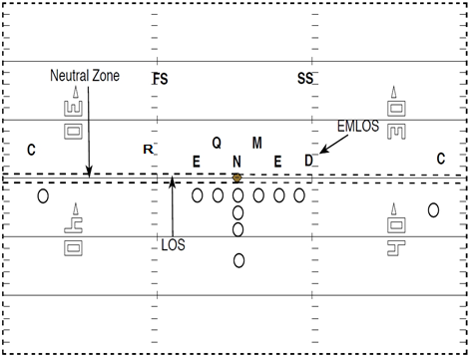
- NZ: Neutral Zone!
- LOS: Line of scrimmage
- PS : Playside
- BS : Backside
- EMLOS : End Man on the line of scrimmage
- Cov : Defensive backs pass coverage
- E : Defesnsive End
- T : Defensive Tackle
- N : Nose Tackle
- M : Mike linebacker or inside linebacker
- Q : Weak side inside linebacker
- R : Rover Weak side outside linebacker
- D : Devil Strong side outside linebacker
- SS : Strong Safety
- FS : Free Safety
- CB : Cornerback

Formation and players positions: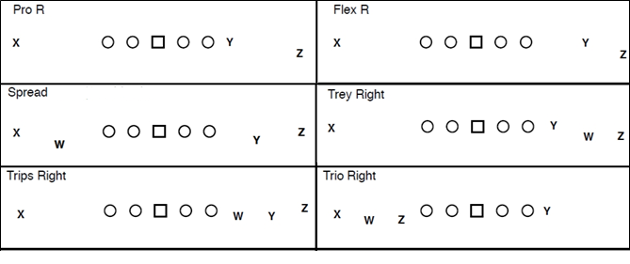

Backfield formations
Halfback
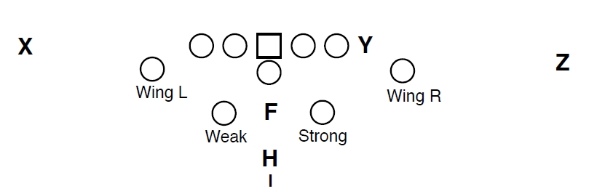
Fullback
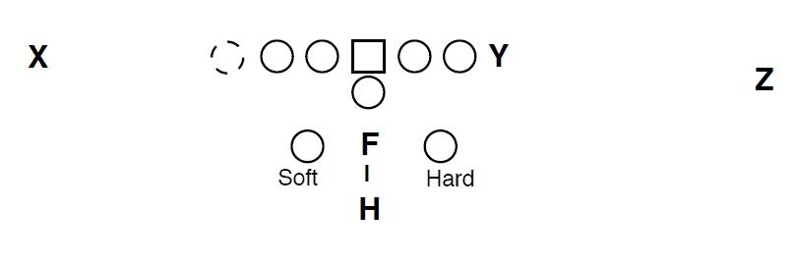

Backfield sets:
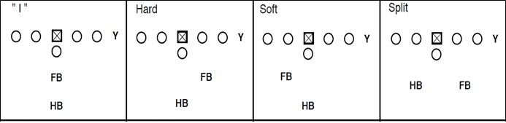
Motion System
All the motion system will work with a number. We will use the running numbers for our motion. If no number is given it means that you will have to go a cross and set up in "Twin " to the closest receiver. If there is no receiver then you set up as a flanker.
- Z motion = Zoom + motion number
- Y Motion = YO + motion number
- T Motion = Tow + motion number
- W Motion = WOW + motion number
- FB Motion = FLY + motion number
- H Motion = HUM + motion number

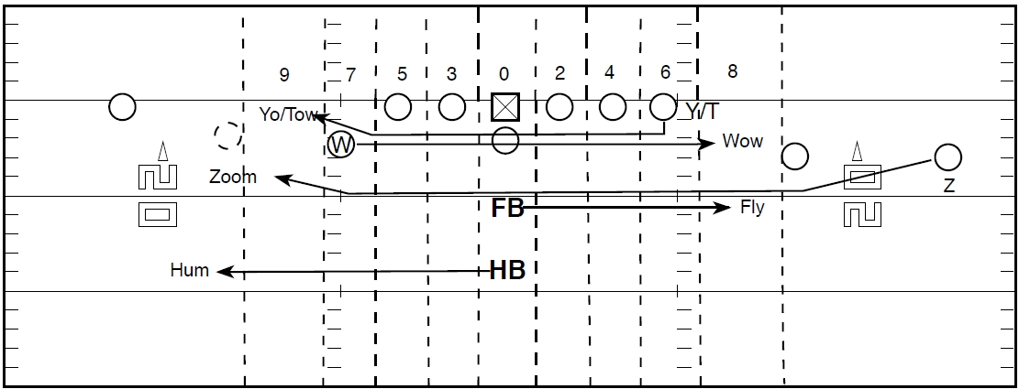

Play calling system
  - Formation
  - Backfield formation
  - Play
  - Motion
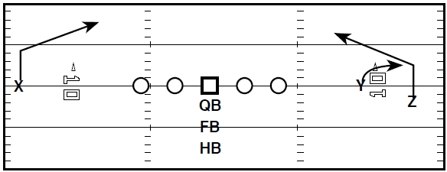
Example:
- Flex Right I 212

Series:
- 10= QB series
- 20= FB series
- 30= HB series
Running Offense
HOLES:
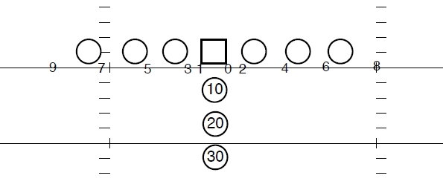
Fullback and Halfback always attack the inside foot of the OL in the called hole.

Blocking system

Our philosophy in gap offense:

We want to put our OL in the best blocking situation therefore our running system is built on a simple rule "attack the „bubble”. The system is the same for all formations and runs.
What’s a bubble? A bubble is a defensive player that is off the LOS in a gap defense:

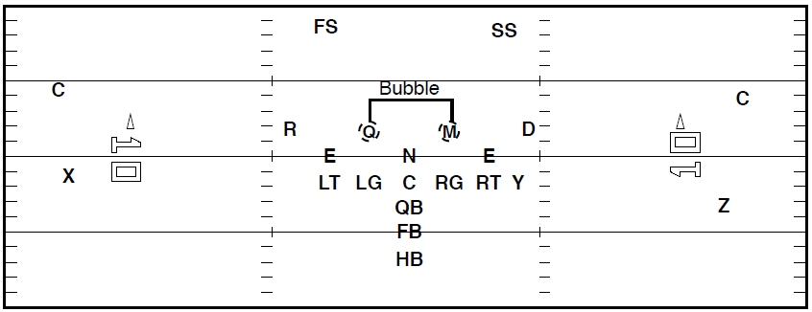

In this system our running game is going to be divided in 3 groups:
    - Runs between 0-5
    - Runs between 6-7
    - Runs between 8-9

A) Runs from 0-5

If we call a run between 0 and 5 and there is a DL sitting in the hole then we will run to the next hole on the outside and attack the bubble.

Example I.:
Pro Right I 32
Since in the 2 gap we have a NT we slide to the next hole where there is a bubble.

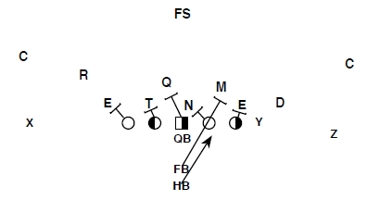

Example II.:
Pro Right I 35
Since in the 5 gap we have a DT we slide to the next hole where there is a bubble.

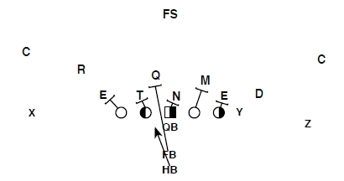

FB Dives:

The same rules apply to FB dives. If we call a run to a gap where a DL is in the hole we will slide one hole.

Example:
Flex R 24
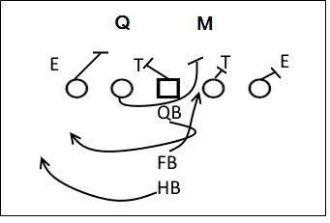
Flex R 23
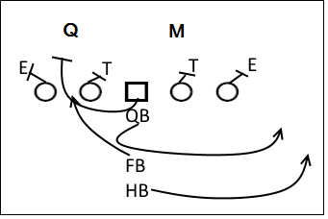

The 23-22 Trap:

No matter what the backfield is (Ace or I) the blocking rules never changes. If there is a DL in the gap we are running we will run to the next hole.

Example:
Pro R Hard 23 trap:
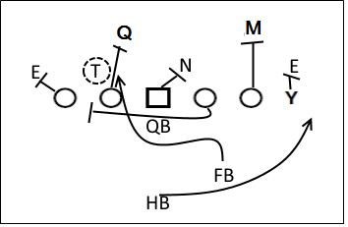
Pro R Hard 23 trap with a DL in 3 hole:
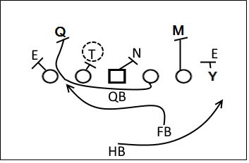

Pro L 35 trap
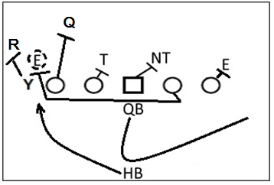

The Wedge

Example
32 wedge

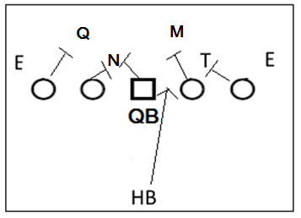

B) Runs to 6-7

On runs outside the tackle the rule is the same, but if we run to the TE side then we will slide the run one gap to the outside.

Example:
Pro Right I 36
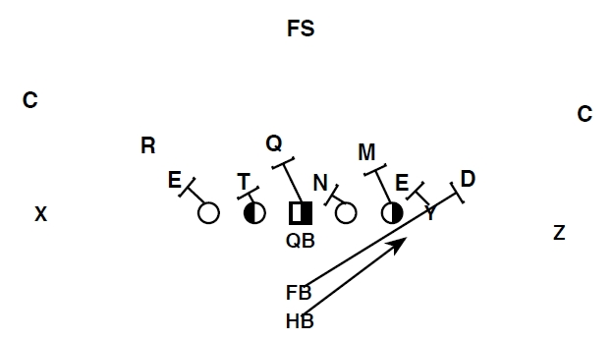

On runs outside the tackle the rule is the same, but if we run to the offtackle and there is no TE we will squeeze one
gap to the inside.

Example:
Pro Right I 37
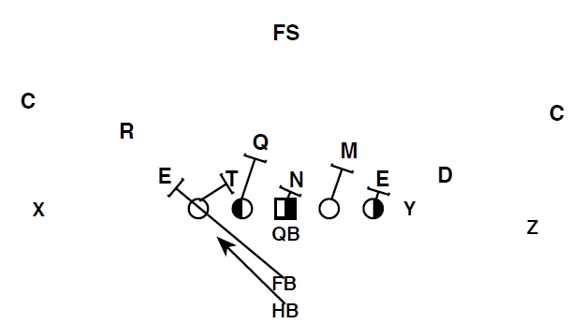

Passing offense
- We will mainly use the FLEX, EXXON, SPREAD, TIGHT SPREAD and TRIPS formations.
Passing tree:

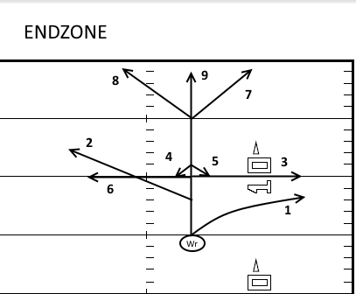
- 1 yard break, run flat towards 3 yards of LOS outside
- 3 yard break at 45 degrees inside
- 5 yard break at 90 degrees outside
- 6 yard break comeback 1 yard to the inside and show yourself
- 6 yard break comeback 1 yard to the outside and show yourself
- 5 yard break at 90 degrees inside
- 8-10 yard break and aim at the end pylon in the back of the endzone
- 8-10 yard break and aim at the goal post
- fly route to the endzone

- In the passing game we will mostly use the numbering system, the number of the route is given from left to right.

Example:
Spread R gun 2112
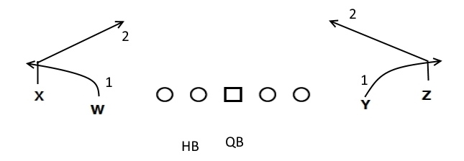

Flex L I 878
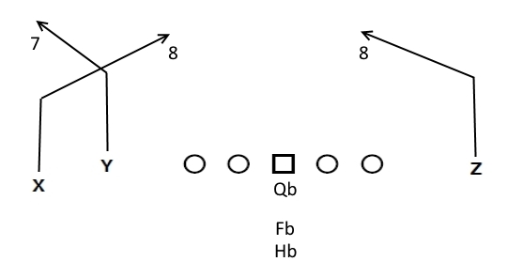
- If you have to motion take the number assignment with you and run the route at the end of the motion.

Example:
Flex R Gun 847 zoom across
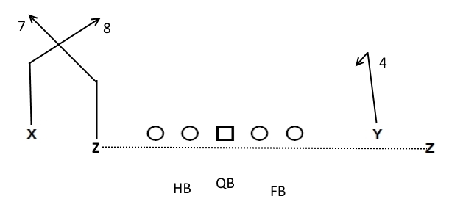

- We have some combined routes for which the route breaks have to be adjusted.
Example:
Flex R 2222
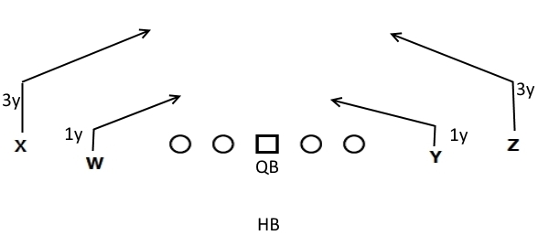
Flex R 4444
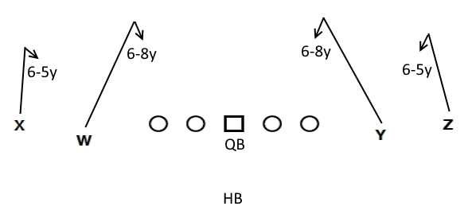
Pass protection:
Our Pass-Protection will be determined according to the defensive front. Always 6 in the PP; 5 offensive linemen and a HB or FB.
We will use:
- Zorro and Zelda – The PP is towards the DT lined up in a 2 tech.
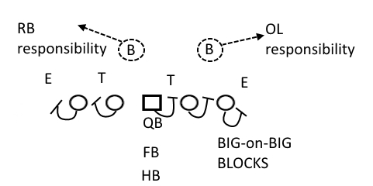

HB will block the Defensive End; FB helps on the Defensive End, and will block any blitz!

Passing concepts:
Always attacking with 4 receivers
If we have a 2 back formation HB will be a plus receiver. On pass protection FB will always have a check before going

- SMASH:

Flex R Gun Smash
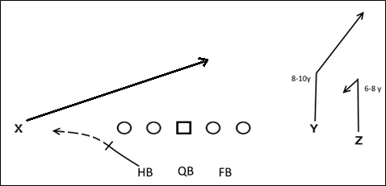

Pro R I Smash
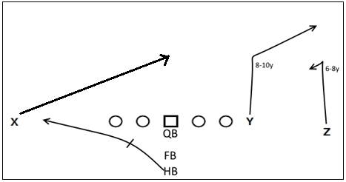

Screen Plays:
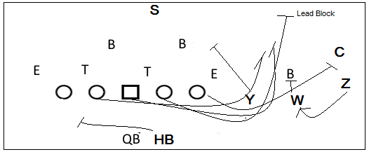

- SEATTLE and FRISCO
These plays are screen plays, Seattle is a screen left; Frisco is a screen right. The number means the receiver from the outside that has to run the screen. If the target receiver is not on the line he must attack the LOS, and then belly back to catch the ball in stride; if the target receiver is on the line he has to run a bubble screen. The other receivers have to crack the defenders!
Empty R Seattle1/Frisco1
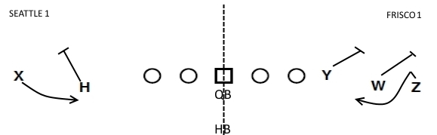
Empty R Seattle2/Frisco2
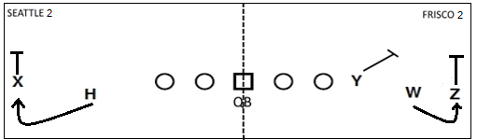
Trips R Frisco3
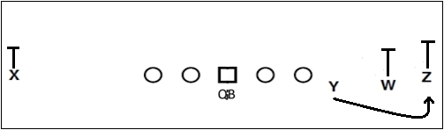

- HB Screen

Flex R HB Screen L
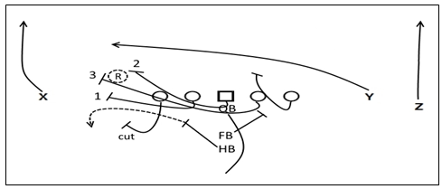
- QB read R backer
- Fire out
- Seal inside
- Lead

Flex L FB Screen R
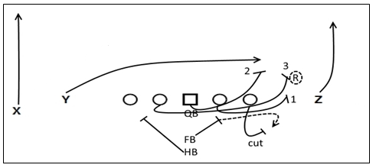
- Fire out
- Seal inside
- Lead

Draw Plays:
- HB Draw
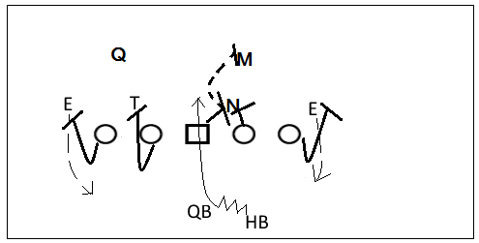

OLine: First step is a pass block then block the second level
OT: keep the END outside
OG: Double team the NT/keep the T outside
C: Double team the NT then the closest LB
HB: First step is like pass protection then handoff
QB: Look downfield like a pass play then handoff

- QB Draw
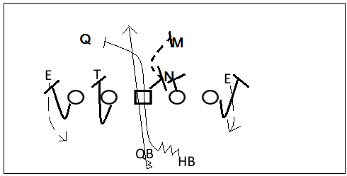
OLine: First step is a pass block then block the second level
OT: keep the END outside
OG: Double team the NT/keep the T outside
C: Double team the NT then the closest LB
HB: First step is like pass protection then second level LB block
QB: Look downfield like a pass play then inside run

